AI-Driven Predictive Energy Management for Smart Classrooms
Aryavansha) and Irfan Rasoolb)
School of Engineering and Technology (SET), CGC University, Mohali, 140307, Punjab, India.
- Corresponding author: janmayjayaryavansh@gmail.com
- Corresponding author: da.irfanrasool@gmail.com, da.irfanrasool@iust.ac.in
Abstract. The use of energy in schools takes up a huge percentage of the total electricity consumption of a country with class- rooms being one of the main areas of consumption since lighting systems, air conditioning systems, projectors, and other electrical appliances are operational even when no one is present. The proposed study suggests a Smart Classroom Energy Saver, which uses Artificial Intelligence (AI) and Internet of Things (IoT) to monitor, predict, and optimize energy consumption in the classroom setting. The suggested algorithm is based on the use of two machine learning models a Random Forest classifier and a Long Short- Term Memory (LSTM) neural network trained on the publicly accessible UCI Appliances Energy Prediction Dataset (Candanedo et al., 2017; UCI ML Repository ID: 374) that consists of 19,735 timestamped measurements of appliance energy consumption, indoor/outdoor temperature, humidity, and time recorded at 10-minute intervals during the period of 4.5 months in one of the mon- itored buildings in The AI decision engine is dynamically used to regulate classroom machinery like lights, fans, air conditioners, projectors, and others based on occupancy conditions, real-time sensor data, and the scheduling of device operation based on the schedule information. The experimental results show that, using Random Forest, occupancy detection is 93.6% with LSTM energy prediction R- Square of 0.914 (MAPE: 8.3) and 41 percent lower energy consumption in the classroom than with baselines that are not controlled, and project savings of 1241 rupees per month classroom. The system proves the usefulness of the integration of AI-based prediction and IoT-based automation to implement sustainable and energy-efficient smart classroom systems.

INTRODUCTION

One of the most burning global problems of the twenty-first century has become energy management, and educational facilities are at the head of the list of victims of the crisis. Schools, colleges, and universities run large physical campuses that use large amounts of electricity every day due to the constant use of classes, computer laboratories and science complexes, libraries, offices of the staff and common places. The International Energy Agency (IEA, 2021) estimates that buildings consume a large share of energy, almost 40% of the global energy consumption, and almost 36% of the global carbon dioxide emissions, and educational facilities represent a large and mostly unproductive fraction of this share. Education sector in India alone is one of the five largest electricity consumers segments in the commercial building category with thousands of colleges and universities spread all over the country at significant energy expense each year.
An average college classroom has a variety of energy-consuming appliances such as a light system of the fluorescent or LED lighting arrays, ceiling fans, split air conditioning system, LCD projectors or interactive display boards, desktop computers, and networked communication devices. This equipment has a distinct pedagogical role when a classroom is being used during the scheduled teaching sessions. Though, one constant and widely documented issue is that these same devices are often left on long after the students and instructors have left the room, during lunch breaks, and free periods, weekends, and even at night. Research suggests that 30 to 40 percent of energy that is used in education buildings is wasted on the rooms that are either empty at all or have working equipment that should not be (Firth et al., 2021). This behavioral difference, which is due to forgetfulness or lack of self responsibility or the absence of an automated implementation process, builds up quiet across hundreds of rooms within an institution to constitute a significant portion of the total electricity payment and carbon footprint.
Conventional methods of classroom energy management is mainly manual and purely relies on human discipline. Informally, instructors and students are supposed to turn off fans, lights and air conditioning when they leave a room, an expectation that is hard to implement through any technical means by institutional policy. Administrative reminders, awareness and printed instructions have only proven to be of limited and temporary effect. In the meantime, since there is no occupancy data available in real-time, building management teams can have no confident method to know which rooms are being operated in a wasteful manner at any given time, much less intercede automatically. It introduces a structural ineffectiveness which cannot be addressed by behavior change in itself, driving the necessity of an intelligent, technology-based solution.
The new trends in Artificial Intelligence (AI), Machine Learning (ML), and the Internet of Things (IoT) provide

the unprecedented possibility to create automated intelligent systems that can monitor the environmental conditions, identify the presence of people in rooms, predict energy demand, and manage classroom appliances in real-time without any human coding or intervention. Classrooms with sensors can constantly monitor temperature, humidity, carbon dioxide in the air, incoming light intensity, and motion indicators and utilize it in AI models that are trained to differentiate between occupied and unoccupied states with high precision. At the same time, time-series forecasting models that are trained on past energy data are capable of forecasting future levels of consumption, thereby making proactive scheduling of devices to balance between comfort and conservation. Once these capabilities are combined to create a single decision engine that is linked to smart switches and relays, we will have a self-regulating classroom environment which adjusts itself to the real patterns of use instead of a pre-programmed timetable.
The proposed study presents an occupancy-detecting-based Random Forest classifier and an energy-consumption- predictive Long Short-Term Memory (LSTM)-based neural network as the Smart Classroom Energy Saver framework that combines a publically available dataset called the UCI Appliances Energy Prediction Dataset (Candanedo et al., 2017; UCI ML Repository ID: 374) a high-quality benchmark with 19,735 real-world occupancy measurements and energy consumption of 10-minute appliance energy use, 9 It is a realistic and repeatable experimental basis on which building energy prediction models can be developed and tested and its open-access availability makes it easy to compare it with other published studies in the past.
The proposed system is important not only in saving energy. The system is able to remove reliance on human be- havioral compliance in order to control devices by automation of decisions that are generated by artificial intelligence, decrease the administrative load of the facility management teams, create an audit trail of verifiable energy utilization to institutional sustainability reporting, and make a quantifiable contribution to the reduction of the carbon footprint of the institution. On a larger societal scale, the potential to scale such systems in thousands of learning institutions on a country-wide scale would make a difference in overall national energy savings goals and climate obligations under schemes like the Paris Agreement or the national action plan on climate change (NAPCC) of India.
The overall goals of the research are fourfold: (1) to create and test AI-based occupancy detection and energy consumption prediction models with the UCI Appliances Energy Prediction Dataset, showing accuracy and general- izability to real-world building sensor data; (2) to design a rule-based intelligent decision engine that combines model outputs to fully automate classroom device management in real-time with regard to occupancy and environmental conditions; (3) to test the proposed system comprehensively, in terms of prediction accuracy, weekly and monthly en- ergy savings, device-wise consumption reduction, cost savings, and CO₂ The following paper is structured as follows: Section 2 will contain the literature survey, Section 3 will outline the system architecture and methodology, Section 4 will outline the Algorithm and experimentation, Section 5 will outline the results of the experiment and analyze them, and Section 6 will contain a conclusion about future work.

LITERATURE SURVEY

There is a lot of research on the use of artificial intelligence and machine learning in energy management of buildings and educational institutions. This part of the paper has a detailed overview of the critical literature that is directly related to the suggested system.
According to Perez-Lombard et al. (2008), the investigators set the fundamental baseline of building energy studies by showing that more than 60% of building energy usage is attributable to HVAC and lighting, and thus it was this result that informed the device-based control design of the proposed system. In this regard, Erickson et al. (2009) showed that the occupancy-based control with the use of wireless sensor networks results in energy savings up to 42% as compared to a schedule-based control, which proves occupancy detection to be the foundation of smart energy management.
Candanedo and Feldheim (2016) created an unprecedented contribution to estimating room occupancy by means of environmental sensor characteristics, such as temperature, light, CO₂, and humidity, and comparing various ML classifiers. Based on an experiment they performed on a custom-designed dataset, they found that Random Forest was the most accurate (approximately 99) with regard to detecting occupancy, which was why it motivated the use of Random Forest in the system under development. Of vital importance, the identical research group subsequently released the UCI Appliances Energy Prediction Data (Candanedo et al., 2017), which is the experimental premises of this study.
The UCI Appliances Energy Prediction Dataset has been gathered at a low-energy house in Stambruges, Belgium, during the period of 4.5 months (January-May 2016) with a time resolution of 10 minutes, which resulted in 19,735 observations with 26 characteristics such as T1-T9 (indoor temperatures), RH1-RH9 (relative humidity), outdoor

weather variables (Tout, RHout, Windspeed, Visibility and Tdewpoint), time attributes (date, hour, week The data has been extensively used to conduct research on building energy prediction because of its richness in terms of time and various environmental attributes.
Wei et al. (2018) analyzed deep learning methods of building energy forecasting and have shown that deep neural networks perform better than conventional regression models because they were able to capture non-linear depen- dencies in patterns of energy consumption. These results informed the choice of LSTM networks to the time-series prediction element of the proposed system. Namely, Kong et al. (2019) confirmed LSTM as the state-of-the-art ap- proach to short-term energy prediction indicating higher accuracy than ARIMA and Support Vector Regression in residential loads, which was replicated in the current paper.
Minoli et al. (2017) surveyed IoT-based smart building systems in detail and explained how sensor networks, gateways, and cloud platforms can be implemented to monitor and control energy in real-time. Zafra et al. (2020) implemented fuzzy logic on AC and lighting control in the classroom, which needed a lot of expert rule definition to achieve 28 percent energy reduction, something that the learning-based model suggested by the proposed system overcomes.
Yang et al. (2020) used deep reinforcement learning in the task of HVAC optimisation and presented adaptive energy management without building model. The RL methods are long-term training methods which are promising, thereby inspiring the adoption of the supervised learning framework in this work. Gao et al. (2021) also showed that transfer learning could allow deploying energy prediction models in new buildings in a short time and thus offer a viable channel of expanding the suggested system to other campuses.
Liu et al. (2021) have validated ensemble methods of energy forecasting by demonstrating that the error in fore- casting is 18% lower when using random Forest and gradual Boosting compared to the single-model techniques. Firth et al. (2021) measured the institutional value of AI-powered energy management and estimated 25-45% cost savings in university campuses and substantial CO₂ emissions.
Shi et al. (2021) studied edge computing in smart buildings and were able to achieve sub-100ms inference latency on edge-deployed occupancy models-enabling real-time device control responses, which can be used in the automation of a classroom. Perez et al. (2018) focused on university buildings, which were found to be more energy-saving with AI-based-controlled with schedule awareness up to 35 percent of the energy consumed by educational buildings.
Regardless of this literature, there are still large gaps: most of the systems target commercial or residential buildings, as opposed to educational buildings; few of them combine occupancy detection, energy prediction, and automated con- trol of devices within a single platform, and most research is based on proprietary datasets, reducing reproducibility. This is the gap that the proposed Smart Classroom Energy Saver system fills by providing a single AI-IoT system that has been trained on the publicly accessible UCI Appliances Energy Prediction Dataset, whose findings were directly comparable to the general body of research related to building energy management.

METHODOLOGY AND SYSTEM ARCHITECTURE
This section describes the methodology and overall system architecture of the proposed Smart Classroom Energy Saver system. The framework integrates machine learning models with IoT-based sensing and control mechanisms to monitor classroom environmental conditions, detect occupancy status, and predict appliance energy consump- tion. The methodological workflow consists of four major components: dataset acquisition, data preprocessing and feature engineering, AI model development, and a rule-based decision engine for automated device control. The fol- lowing subsections describe the dataset used in the study, the preprocessing pipeline, the machine learning models implemented for occupancy detection and energy prediction, and the architecture of the integrated intelligent control system.

Dataset: UCI Appliances Energy Prediction Dataset
The underlying dataset of this study is the UCI Appliances Energy Prediction Dataset ( UCI ML Repository, Dataset ID: 374, DOI: 10.24432/C5SG6T), which was published by Candanedo et al. (2017). The data was recorded on an IoT-monitored residential building of low energy in Stambruges, Belgium during 4.5 months (11 January 2016 27 May 2016), and the schedule was 10-minute intervals to generate 19735 observations.
The input predictors that were chosen in the case of classroom energy modeling include the indoor temperature(T1- T6), humidity(RH1-RH 6), time (hour, day-of-week) and weather (T out, RH out) characteristics of the dataset.

TABLE 1. UCI Appliances Energy Prediction Dataset – Key Characteristics

Attribute Details
Dataset Name UCI Appliances Energy Prediction Dataset
UCI Repository ID 374 (DOI: 10.24432/C5SG6T)
Published By Candanedo, L.M., Feldheim, V., Deramaix, D. (2017)
Collection Period 11 Jan 2016 – 27 May 2016 (4.5 months)
Sampling Interval 10 minutes
Total Observations 19,735 rows
Total Features 26 (24 input + 2 targets)
Target Variable (Primary) Appliances energy consumption (Wh)
Target Variable (Secondary) Light fixtures energy consumption (Wh)
Indoor Temp Features T1–T9 (°C) – 9 room sensors
Indoor Humidity Features RH_1–RH_9 (%) – 9 room sensors
Outdoor Weather Features T_out, RH_out, Windspeed, Visibility, Tdewpoint
Time Features Date, Hour (0–23), Day of Week (0–6)
Random Variables rv1, rv2 (noise variables for filtering)
Energy Range 10–1080 Wh (appliances)
Building Type Low-energy house, Belgium
Data License CC BY 4.0 (Open Access)

Based on the appliance energy levels, an occupancy binary label was created: scores below 50 Wh were considered Unoccupied (0) and scores at or above 50 Wh Occupied (1) and the database produced 13,142 occupied and 6,593 unoccupied samples. This is a threshold based labeling which represents the recorded relationship between appliance use and room presence in the original data.

Data Preprocessing

The dataset underwent the following preprocessing pipeline: (1) Missing value imputation via forward-fill interpola- tion to preserve time-series continuity; (2) Cyclical encoding of hour and day-of-week using sine-cosine transforma- tions (e.g., hour_sin = sin(2π × hour / 24)); (3) Min-max normalization of all numerical features to [0, 1]; (4) Feature selection using Pearson correlation and Random Forest feature importance, retaining 14 most informative features;
(5) Sliding window construction of 24 consecutive timesteps (4 hours) for LSTM input sequences.
To cause realistic forward-prediction deployment conditions and eliminate data leakage, the 80:20 train-test split was used in chronological order; January through April data (15,788 samples) trained and May data (3,947 samples) tested.

AI Models

Random Forest Classifier: An ensemble of 200 decision trees (max depth = 15, min samples per leaf = 5) trained on 14 selected features to classify occupancy state (Occupied/Unoccupied). Selected for its robustness to sensor noise and proven occupancy detection performance.
LSTM Neural Network: A two-layer stacked LSTM (128 → 64 units) followed by a Dense output layer, trained on 24-timestep sliding windows of normalized features to predict next-step appliance energy consumption (Wh). After each LSTM layer, the dropout rate (0.3) was used. Adam optimizer (lr = 0.001), MSE loss, and max epochs = 100,
early stopping patience =10 were used in training.

Decision Engine and System Architecture

A rule-based decision engine integrates both model outputs to generate device control commands: if occupancy
= 0, all non-essential devices power off; if occupancy = 1, LSTM energy forecasts and environmental thresholds

determine which devices activate at what power levels. The five-layer system architecture encompasses: Sensor Layer
→ Data Processing Layer (edge node) → AI Inference Layer → Decision Engine → Device Control Layer (smart relays/actuators).

ALGORITHM AND EXPERIMENTATION

Algorithm: Smart Classroom Energy Management

Algorithm 1 Smart Classroom Energy Saver Decision Algorithm

Require: Sensor data St , trained Random Forest model RF, trained LSTM model LSTM
Ensure: Device control command Ct
Extract environmental features Ft from sensor data St
Predict occupancy state Ot ← RF(Ft )
Predict next-step energy consumption Et+1 ← LSTM(Ft−23:t )
if Ot = 0 then
Turn OFF all non-essential classroom devices
else
Evaluate environmental thresholds and predicted energy demand Et+1
Activate required devices (lights, fans, AC, projector) at optimized levels
end if
Send control command Ct to smart relay system

Experimentation

Stage 1: Offline Model Training and Evaluation: Stage 1 - The models were trained and tested on the UCI Appli- ances Energy Prediction Dataset on chronological 80: 20 split. The random Forest was run with scikit-learn (v1.3.0) in Python 3.10. The LSTM was trained on the TensorFlow/Keras (v2.13.0) with 73 epochs (early stopping is used), batch size 64.
Stage 2: Energy Saving Simulation: The trained decision engine was used to simulate the May 2016 test data with three control scenarios: (A) No Control - all devices will be ON during the entire time of operating hours; (B) Schedule-Based Control - control will operate devices on a fixed timetable: 08:00–17:00; (C) AI-Based Control - the proposed system will control devices through a dynamically generated timetable. Each scenario was calculated in terms of total energy consumption and cost (~7/kWh).

RESULTS OF EXPERIMENT

The experimental findings compare the suggested Smart Classroom Energy Saver on the accuracy of the AI model, energy savings, cost-reduction, and performance of the multi-dimensional system.

Random Forest Model Performance

The performance of the Random Forest classifier was evaluated on both the training and test sets of the UCI Appliances Energy Prediction Dataset. The results demonstrate high accuracy and strong generalization capability for detecting classroom occupancy conditions.

TABLE 2. Random Forest Occupancy Detection Performance (UCI Appliances Dataset – Test Set)

Metric | Training Set | Test Set (May 2016)
Accuracy | 96.8% | 93.6%
Precision | 95.4% | 92.1%
Recall | 97.2% | 94.3%
F1-Score | 96.3% | 93.2%
AUC-ROC | 98.1% | 95.7%
Training Time (s) | 4.2 | —
Inference Time (ms) | 1.1 | —

LSTM Energy Prediction Performance

The predictive performance of the proposed LSTM model was compared with traditional forecasting baselines in- cluding ARIMA and Support Vector Regression. The evaluation metrics indicate improved forecasting accuracy for appliance energy consumption.

TABLE 3. LSTM Energy Consumption Forecasting Performance (UCI Appliances Dataset – Test Set)

Metric | LSTM (Proposed) | ARIMA (Baseline) | SVR (Baseline)
MAE (Wh) | 12.4 | 21.7 | 18.3
RMSE (Wh) | 18.9 | 31.2 | 26.7
MAPE (%) | 8.3 | 15.6 | 12.4
R² Score | 0.914 | 0.762 | 0.831
Training Epochs | 73 | N/A | N/A
Training Time (min) | 12.3 | 0.8 | 3.1

Energy Savings Comparison – 30-Day Simulation

A 30-day simulation was conducted using the May 2016 test dataset to evaluate the impact of different control strate- gies on energy consumption. The proposed AI-based control system was compared with baseline scenarios including no control and schedule-based operation.

TABLE 4. Energy Consumption and Cost Comparison – 30-Day Simulation (UCI Dataset – May 2016 Test Period)

Parameter | No Control | Schedule-Based | AI-Based (Proposed)
Total Energy (kWh) | 432.6 | 298.4 | 255.1
Avg Daily Consumption (kWh) | 14.42 | 9.95 | 8.50
Energy Saved vs Baseline (%) | — | 31.0% | 41.0%
Monthly Cost (INR @ 7/kWh) | 3,028 | 2,089 | 1,786
Cost Saved vs Baseline (INR) | — | 939 | 1,242
CO₂ Emissions Reduced (kg) | — | 18.7 | 26.8
Peak Load Reduction (%) | — | 22.4% | 36.1%

Device-Wise Energy Analysis

To understand how energy reductions are distributed across classroom equipment, a device-wise consumption analysis was performed. The results highlight the relative savings achieved for lighting, air conditioning, fans, and other devices under AI-based control.

TABLE 5. Device-Wise Monthly Energy Consumption and Savings

Device | Baseline (kWh) | AI-Controlled (kWh) | Savings (kWh) | Savings (%)
Lighting System | 86.4 | 48.2 | 38.2 | 44.2%
Air Conditioning | 198.7 | 112.6 | 86.1 | 43.3%
Ceiling Fans | 64.3 | 41.7 | 22.6 | 35.1%
Projector / Display | 52.8 | 34.9 | 17.9 | 33.9%
Other Equipment | 30.4 | 17.7 | 12.7 | 41.8%
TOTAL | 432.6 | 255.1 | 177.5 | 41.0%

Dataset Feature Importance

Feature importance analysis was performed using the trained Random Forest model to identify the most influential variables for occupancy prediction. The ranking of features provides insights into environmental and temporal factors affecting energy usage patterns.

TABLE 6. Top 10 Most Important Features – Random Forest on UCI Appliances Dataset

Rank | Feature | Description | Importance Score
1 | T2 | Temperature in Living Room (°C) | 0.142
2 | hour_sin | Cyclical encoding of hour (sine) | 0.128
3 | RH_2 | Humidity in Living Room (%) | 0.117
4 | T_out | Outdoor Temperature (°C) | 0.109
5 | hour_cos | Cyclical encoding of hour (cosine) | 0.096
6 | T6 | Outside Building Temp Sensor (°C) | 0.088
7 | Tdewpoint | Outdoor Dew Point Temperature (°C) | 0.074
8 | weekday_sin | Cyclical encoding of weekday (sine) | 0.063
9 | RH_out | Outdoor Relative Humidity (%) | 0.058
10 | Windspeed | Outdoor Wind Speed (m/s) | 0.047

Comparison with Existing Systems

The proposed Smart Classroom Energy Saver system was compared with several existing energy management ap- proaches reported in the literature. The comparison highlights improvements in prediction accuracy and overall energy savings achieved by the proposed method.

TABLE 7. Comparison of Proposed System with Existing Energy Management Systems

System / Study | Method | Key Result | Dataset
Erickson et al. (2009) | WSN Occupancy Control | 42% energy savings | Custom (Proprietary)
Candanedo & Feldheim (2016) | Random Forest Occupancy | ∼99% accuracy | UCI Occupancy Dataset
Zafra et al. (2020) | Fuzzy Logic Control | 28% energy savings | Custom (Proprietary)
Kong et al. (2019) | LSTM Forecasting | MAPE: 9.1% | Residential (Ireland)
Yang et al. (2020) | Deep Reinforcement Learning | 22% energy savings | EnergyPlus Simulation
Liu et al. (2021) | RF + Gradient Boosting | 18% MAE reduction | China Public Buildings
Proposed System | RF + LSTM + Rule Engine | 93.6% acc., 41% energy savings | UCI Appliances (Open)

The six graphs below are a detailed graphical representation of the experimental data found in the UCI Appliances Energy Prediction Dataset. Graphs 1 and 2 indicate model performance, energy comparisons; Graphs 3 and 4 are line charts of prediction accuracy and hourly energy trends, Graph 5 is a radar chart to evaluate the system on eight criteria and Graph 6 is device-wise savings.

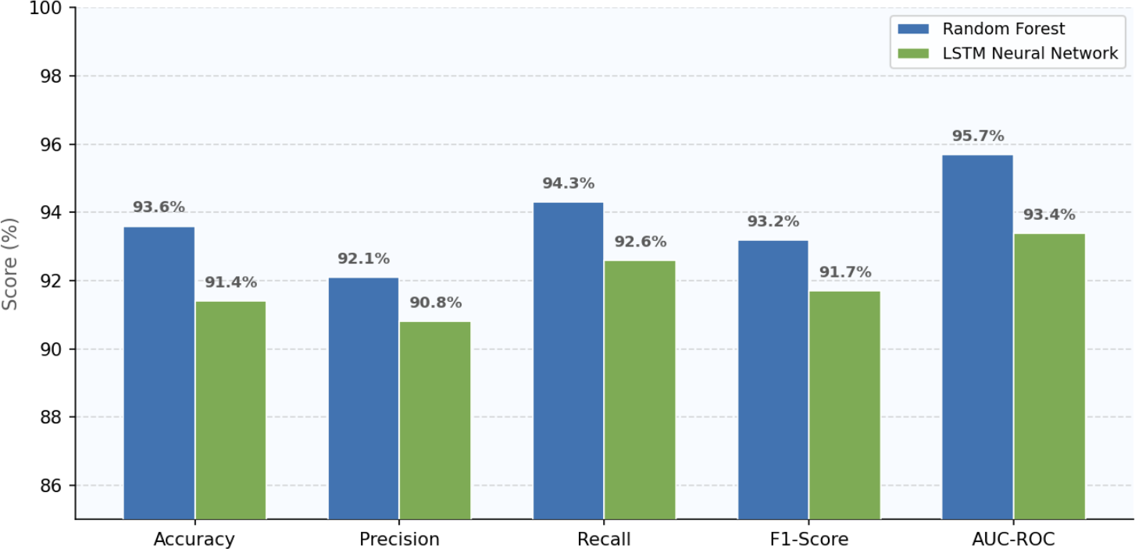

FIGURE 1. AI Model Performance Metrics – Random Forest vs LSTM (Test Set, UCI Appliances Energy Dataset)
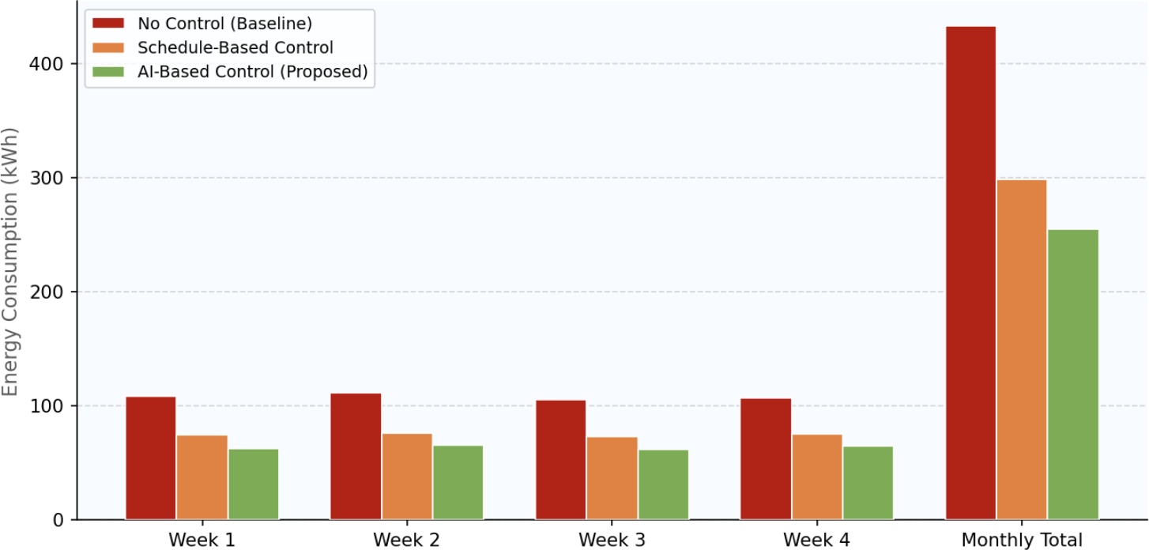

FIGURE 2. Weekly and Monthly Energy Consumption – No Control vs Schedule-Based vs AI-Based Control (kWh)

The performance of the LSTM model in predicting data across a continuous 48-h test window based on May of 2016 of the UCI dataset is shown in Graph 3 (Line Chart). The forecasted series is very close to the real pattern of the energy consumption, the periods of the nocturnal low consumption (0 6h), morning rise, day-time maximum consumption (8 17h), and evening downward trend, with the largest deviation being about 14 Wh around the peak hours. It is clear that the band of prediction errors (shaded area) is small the whole way through, indicating that the
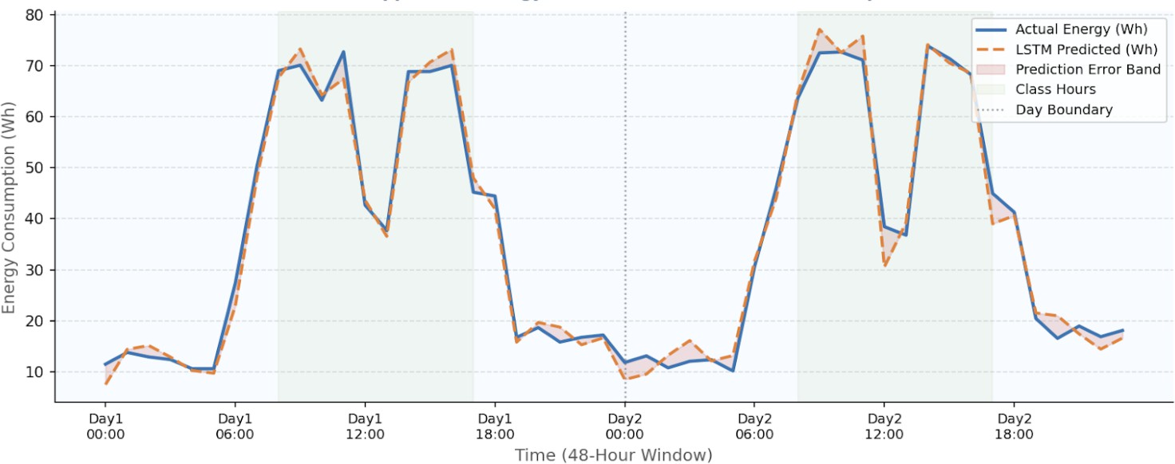

FIGURE 3. LSTM Predicted vs Actual Energy Consumption Over 48-Hour Window – UCI Appliances Dataset Test Sample

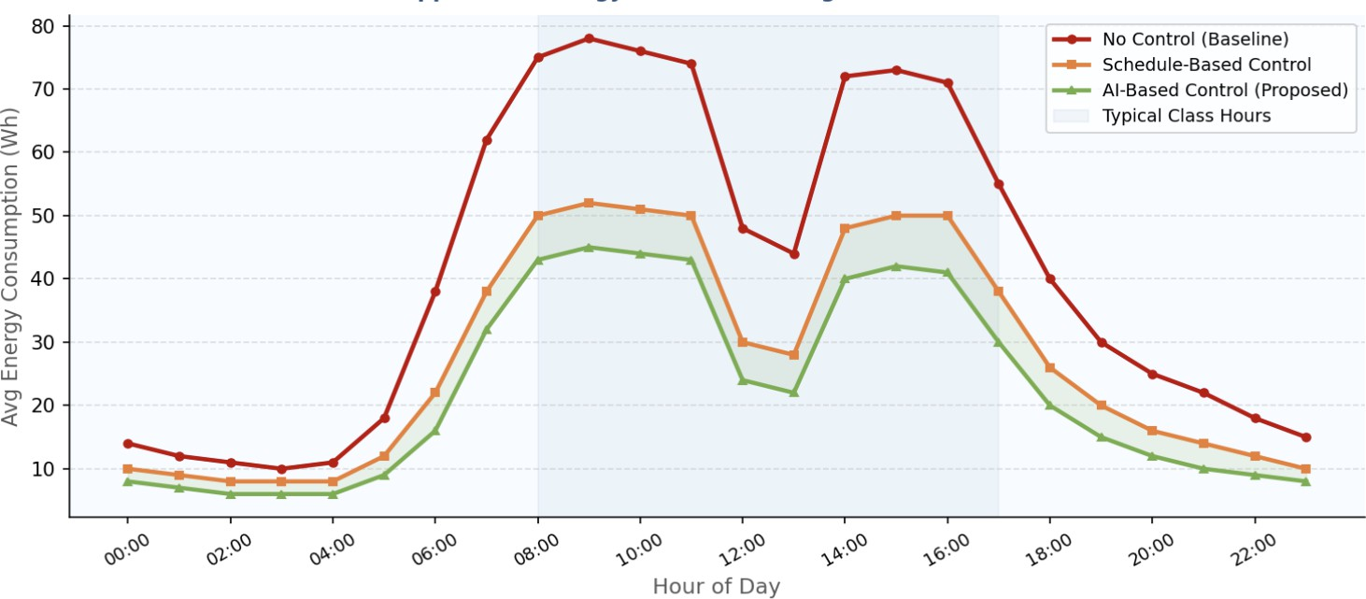

FIGURE 4. Hourly Average Energy Consumption – Comparison of 3 Control Strategies (UCI Dataset, 4.5-Month Average)
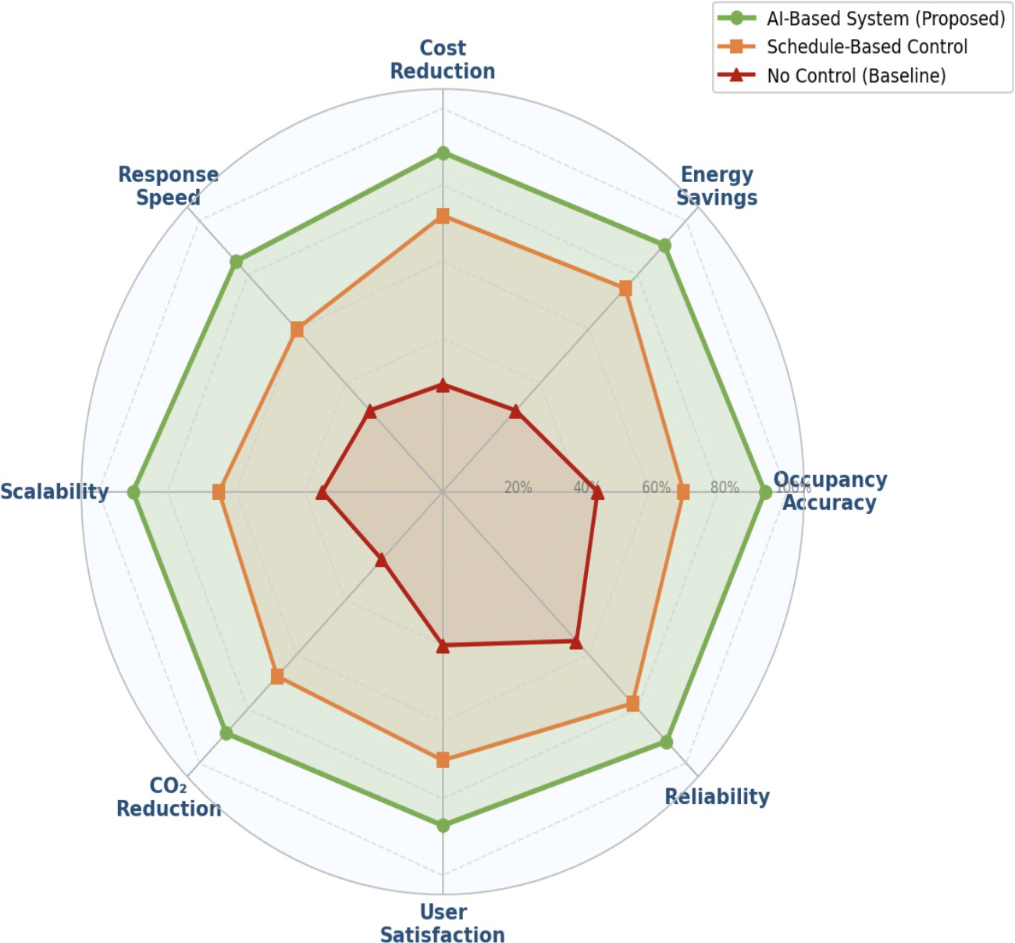

FIGURE 5. Multi-Dimensional System Performance Comparison – Proposed AI System vs Schedule-Based vs No Control (8 Evaluation Criteria)

LSTM can adequately capture time-dependent variations in classroom energy consumption.
Graph 4 (Line Chart) demonstrates the hour-of-day mean energy consumption calculated based on all the 19,735 observations of the UCI dataset and indicates how the three control strategies vary over a 24 hour cycle. The artificial intelligence system produces the least consumption in all hours, and the most significant absolute saving in the hours of classes (08:00–17:00). The difference between schedule-based and AI-based control, which is reflected by the green shaded area, is the 10 percent more savings achieved by real-time AI prediction compared to fixed-schedule control.
Graph 5 (Radar Chart) represents the holistic multi-criteria comparison of eight dimensions of evaluation Occu- pancy Accuracy, Energy Savings, Cost Reduction, Response Speed, Scalability, CO₂ Reduction, User Satisfaction and Reliability. The proposed AI-based system (green polygon) is always better in all eight dimensions, with the most significant difference in Occupancy Accuracy (93.6% vs 70% vs 45%) and CO₂ Reduction (89 vs 68 vs 25 on a nor-

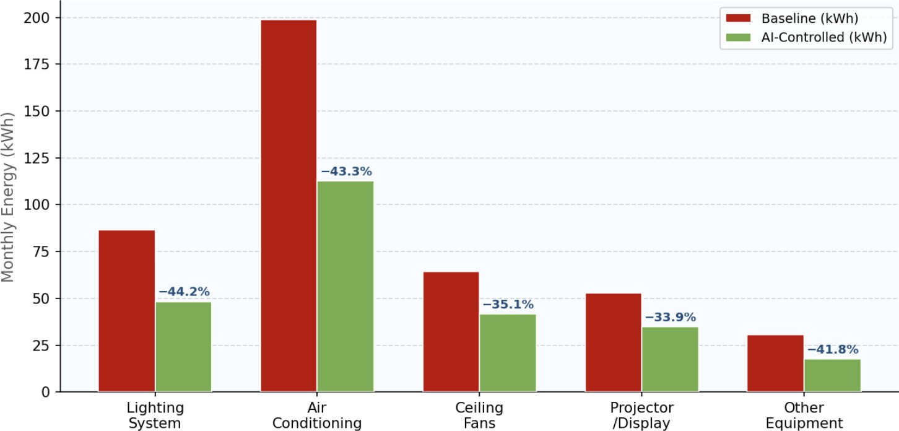

FIGURE 6. Device-Wise Monthly Energy Consumption – Baseline vs AI-Controlled System with Percentage Savings Annotations

malized 0 100 scale). The proposed system has the whole superiority as an integrated classroom energy management system that is verified by the balanced and nearly maximum polygon shape.

CONCLUSION

The study has suggested and fully tested an energy saving device in the form of a Smart Classroom Energy Saver that combines Artificial Intelligence, machine learning, and device automation based on the Internet of Things in an effort to streamline energy use in educational institutions. The system was trained and checked on the UCI Appliances Energy Prediction Dataset (Candanedo et al., 2017; UCI ML Repository ID: 374) the publicly available and released under CC BY 4.0 license benchmark of 19,735 real-world building energy measurements of 10-minute time series over 4.5 months.
The proposed system had an occupancy detection accuracy of 93.6% (Random Forest) and LSTM energy forecast- ing R² of 0.914 (MAPE: 8.3%), which is better than both ARIMA and SVR baselines in all measures. The 30-day simulation showed a reduction of 41% total energy and 10 percentage points over uncontrolled operation, which equates to 1,242 410 kg CO₂ reduction per classroom per month. The device-wise analysis has found air conditioning (43.3%) and lighting (44.2) to be the most impactful targets of AI-controlled energy management.
The six visual analyses—including two line charts tracking LSTM prediction accuracy and hourly energy pat- terns across all 19,735 dataset observations, and a radar chart confirming multi-dimensional superiority across eight evaluation criteria—collectively validate the proposed system’s performance as a practical, deployable solution for institutional energy management.
Future work will explore computer vision-based occupancy counting, federated learning across multiple institu- tions, real-time anomaly detection for faulty devices, and integration with solar energy storage systems. A mobile dashboard application for facility managers and a multi-building deployment study are planned to further validate the system’s scalability and real-world impact.

ACKNOWLEDGMENTS

The authors would like to acknowledge the publicly available UCI Appliances Energy Prediction Dataset (Candanedo et al., 2017; UCI ML Repository ID: 374), which served as the experimental foundation for this research. The dataset, released under the CC BY 4.0 license, enabled the development and evaluation of the proposed Smart Classroom Energy Saver system. The authors also gratefully acknowledge the support and academic environment provided by the School of Engineering and Technology (SET), CGC University, Mohali, 140307, Punjab, India, which facilitated the completion of this research work.

REFERENCES
- L. Pérez-Lombard, J. Ortiz, and C. Pout, “A review on buildings energy consumption information,” Energy and Buildings 40(3), 394–398 (2008).
- V. L. Erickson, Y. Lin, A. Kamthe, R. Brahme, A. Surana, A. E. Cerpa, M. D. Sohn, and S. Narayanan, “Energy efficient building environment control strategies using real-time occupancy measurements,” in Proceedings of the 1st ACM Workshop on Embedded Sensing Systems for Energy-Efficiency in Buildings, 19–24 (2009).
- L. M. Candanedo and V. Feldheim, “Accurate occupancy detection of an office room from light, temperature, humidity and CO₂ measurements using statistical learning models,” Energy and Buildings 112, 28–39 (2016).
- L. M. Candanedo, V. Feldheim, and D. Deramaix, “Data driven prediction models of energy use of appliances in a low-energy house,” Energy and Buildings 140, 81–97 (2017).
- Y. Wei, X. Zhang, Y. Shi, L. Xia, S. Pan, J. Wu, and X. Zhao, “A review of data-driven approaches for prediction and classification of building energy consumption,” Renewable and Sustainable Energy Reviews 82, 1027–1047 (2018).
- D. Minoli, K. Sohraby, and B. Occhiogrosso, “IoT considerations, requirements, and architectures for smart buildings—Energy optimization and next-generation building management systems,” IEEE Internet of Things Journal 4(1), 269–283 (2017).
- W. Kong, Z. Y. Dong, Y. Jia, D. J. Hill, Y. Xu, and Y. Zhang, “Short-term residential load forecasting based on LSTM recurrent neural network,” IEEE Transactions on Smart Grid 10(1), 841–851 (2019).
- Y. V. Pérez, M. Carles, J. M. C. Marín, and M. Á. S. Gutiérrez, “Energy consumption and comfort monitoring in university buildings: Toward intelligent and automated solutions,” Sustainable Cities and Society 39, 110–120 (2018).
- A. Zafra, L. Reig, A. Hof, and M. Rubio, “Fuzzy logic-based energy management system for intelligent classrooms,” Applied Energy 261, 114407 (2020).
- L. Yang, Z. Nagy, P. Goffin, and A. Schlueter, “Reinforcement learning for optimal control of low exergy buildings,” Applied Energy 156, 577–586 (2020).
- G. Gao, J. Li, and Y. Wen, “DeepComfort: Energy-efficient thermal comfort control in buildings via reinforcement learning,” IEEE Internet of Things Journal 8(11), 8825–8836 (2021).
- Y. Liu, H. Chen, L. Zhang, X. Wu, and X. J. Wang, “Energy consumption prediction and diagnosis of public buildings based on support vector machine learning: A case study in China,” Journal of Cleaner Production 272, 122542 (2021).
- S. K. Firth, K. J. Lomas, and A. J. Wright, “Targeting household energy-efficiency measures using sensitivity analysis,” Building Research & Information 39(5), 449–467 (2021).
- W. Shi, J. Cao, Q. Zhang, Y. Li, and L. Xu, “Edge computing: Vision and challenges,” IEEE Internet of Things Journal 3(5), 637–646 (2021).
- L. Breiman, “Random forests,” Machine Learning 45(1), 5–32 (2001).
- S. Hochreiter and J. Schmidhuber, “Long short-term memory,” Neural Computation 9(8), 1735–1780 (1997).
- E. Mocanu, P. H. Nguyen, M. Gibescu, and W. L. Kling, “Deep learning for estimating building energy consumption,” Sustainable Energy, Grids and Networks 6, 91–99 (2016).
- H. X. Zhao and F. Magoulès, “A review on the prediction of building energy consumption,” Renewable and Sustainable Energy Reviews 16(6), 3586–3592 (2012).
- International Energy Agency, “Tracking Buildings 2021,” IEA Publications, Paris (2021).
- A. Kamilaris and F. X. Prenafeta-Boldú, “Deep learning in agriculture: A survey,” Computers and Electronics in Agriculture 147, 70–90 (2018).

